Guidelines: Continuing professional development

Effective from: 1 December 2019
Introduction
These guidelines provide information about how to meet the Occupational Therapy Board of Australia’s (the Board) minimum annual continuing professional development (CPD) requirements outlined in the Registration standard: Continuing professional development (CPD standard). You are expected to understand and apply these guidelines together with the CPD standard.
The public have the right to expect that occupational therapists will provide competent and up-to-date services. CPD helps occupational therapists to maintain their competence and to provide safe and effective health services.
Do these guidelines apply to me?
These guidelines apply to all registered occupational therapists, except those with student and non-practising registration.
What must I do?
You must undertake a minimum of 20 hours of CPD to meet the Board’s registration standard each year.
Summary
These guidelines will help you:
- understand the importance of CPD in staying up to date, maintaining safe practice and improving patient/client outcomes
- choose effective CPD that meets the registration standard, and
- keep CPD records, by providing advice about what information to include in a template portfolio for recording your learning goals, CPD activities and reflections.
Effective CPD and why it is important
Learning and development occurs throughout an occupational therapist’s career. CPD is an important foundation of lifelong learning and helps occupational therapists to maintain their competence to practise.
Effective CPD promotes genuine learning. Genuine learning occurs when you apply what you have learnt in your practice. It facilitates more effective clinical care, leading to safer outcomes for patients and clients.
Research indicates that CPD may be more effective when it involves planning and reflection. Reflection means thinking carefully about your CPD, what you learnt and how you might use it to improve your practice as an occupational therapist. The CPD standard requires you to maintain a portfolio that records your reflections on how CPD has affected your practice.
Benefits of interactive and interprofessional CPD
The CPD standard requires you to complete at least five hours of interactive CPD activities, as there is some evidence that this facilitates effective learning. It also helps to maintain connections with other practitioners and contemporary practice. Interactive CPD activities are any activities that involve other practitioners, such as face-to-face education in person or through technologies such as web conferencing.
Interprofessional CPD activities can also have benefits by supporting effective interprofessional practice which, in turn, optimises health services, strengthens health systems and improves health outcomes.
CPD activities
All CPD which helps you maintain competence, stay up to date and is relevant to your scope of practice will meet the standard.
Learning occurs through a wide variety of CPD activities. Examples include, but are not limited to:
- higher education/accredited courses
- conferences, forums and seminars
- undertaking research and presentation of work
- online learning and internet research
- written reflections on experience in day-to-day clinical practice
- reading books and journals relevant to your practice
- quality assurance activities, such as accreditation, clinical audit or review of records
- participation in committees relevant to your practice
- work-based learning contracts and employment-related professional development
- professional or interprofessional interactions such as meetings e.g. case reviews, clinical forums (may be online or face-to-face), and
- current or emerging health priority areas, for example, cultural safety particularly for Aboriginal and Torres Strait Islander Peoples. Another example is effectively identifying and responding to family violence.
Undertaking your day-to-day routine work duties cannot be counted as CPD.
Planning and reflection
The CPD standard requires you to:
- plan and record your learning goals and the activities that you will do to meet these goals, and
- complete the CPD activities and record a reflection on how they improved your practice.
When planning your CPD you may find it useful to:
- review best practice standards or evidence-based practice. This will enable you to evaluate and improve your level of competency, treatment plan or service delivery
- identify changes in the profession including standards of care
- undertake a self-assessment to identify possible areas for improvement. This will help you to improve your practice to meet current standards using evidence-based practice or best practice standards
- identify how you could further develop competency or strengths in areas of particular interest or aptitude, and
- identify opportunities for interactive and interprofessional CPD.
You may wish to consider current or emerging health priorities, and you should also consider any priority areas identified by your Board, for example, cultural safety for Aboriginal and Torres Strait Islander peoples.
There is good evidence suggesting that reflecting on how your CPD relates to your practice may improve your learning. This can be done by:
- briefly summarising the CPD activities you have completed
- assessing your progress against your learning goals, and
- describing how you have used what you learnt in your practice.
Reflecting on your learning will help you set learning goals for the coming year as part of the ongoing CPD cycle.
It is often helpful to discuss your CPD planning with colleagues, mentors and/or supervisors to help you identify your own areas for improvement. Patient feedback may also be helpful in identifying areas where you need further professional development.
A template CPD portfolio that can help you to record your learning goals, your CPD activities and your reflections can be found on the Board’s website. Examples of completed CPD portfolios are also published on the Board’s website.
It is your responsibility to make sure you meet the CPD standard. You must undertake the required minimum number of CPD hours and your CPD portfolio must include planning and reflection.
The diagram below demonstrates the CPD cycle.
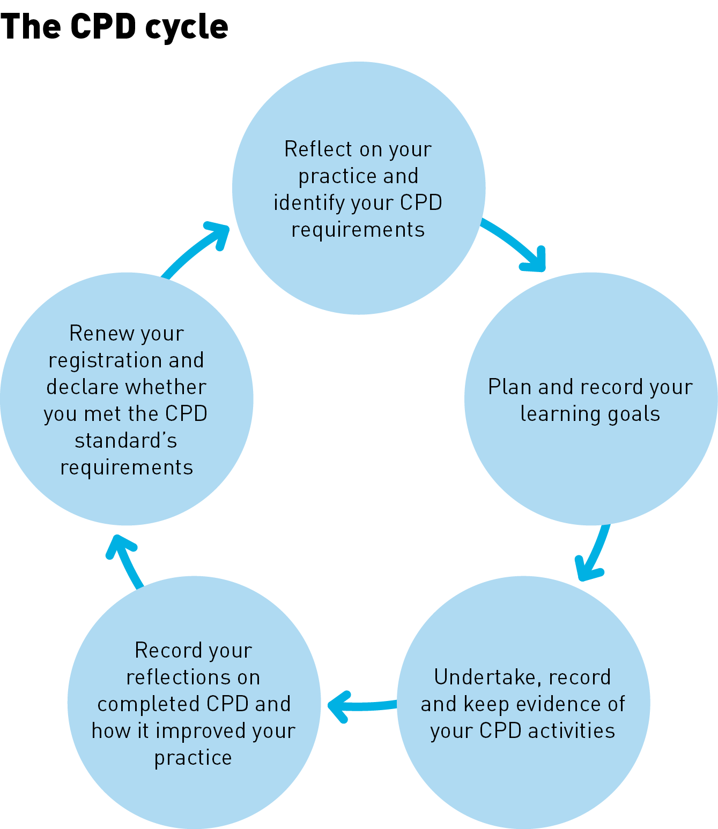

Record keeping
The CPD standard requires you to keep records of your CPD portfolio and your CPD activities for at least five years from the date you completed the CPD cycle. These records must be available for audit or if required by the Board as part of an investigation arising from a notification (complaint).
You must also keep evidence of CPD activities completed, such as:
- certificates of attainment or attendance, and
- your notes from the CPD activity such as conducting a literature review, or reading case studies or journal articles. In this example, it is expected that these notes will provide a comprehensive summary of the key points of the review and reflect your learning from this activity.
Pro rata CPD
Occupational therapists who are registered part-way through a registration period must complete a minimum of five hours of CPD for every three months of registration remaining in the registration period.
Exemption
The Board believes the range of activities and the time frame provided to meet the CPD requirements is flexible enough for occupational therapists to meet the requirements other than in exceptional circumstances.
However, under the CPD standard, the Board may consider and/or grant a full or partial exemption or variation from the CPD requirements in exceptional circumstances. Exceptional circumstances for exemptions will only be considered where there is compelling evidence that the circumstances have prevented the practitioner from practising and created a significant obstacle to the occupational therapist’s ability to complete CPD.
In the case of parental leave the Board may grant a full or partial exemption or variation from the CPD requirements if the circumstances associated with an absence from practice are sufficient to prevent the practitioner from undertaking their CPD. The occupational therapist would need to provide compelling reasons to the Board supported by evidence to show why they are prevented from meeting their CPD requirements. The assessment for granting full or partial exemptions from the CPD requirements is done on a case by case basis and will depend on the individual’s circumstances and reasons provided. Further information about exemptions can be found in the Board’s Fact sheet: CPD exemptions.
You should submit an Application for exemption form to the Board as soon as possible after you identify the need for an exemption. The application must include the nature of, evidence for and time period of the exceptional circumstances involved.
Absence from practice
If you take a period of leave while you remain registered to practise, you are still required to meet the Board’s CPD standard unless you are granted an exemption.
If you move to non-practising registration or don’t maintain your registration, before you re-apply for registration to practise you are encouraged to assess what changes have occurred in your profession and if there is any professional development you need to do to ensure that you are prepared to return to practice.

Compliance
As the CPD registration standard explains:
- when you renew your registration, you are required to declare if you have met the requirements of the CPD standard
- your compliance with this standard may be audited from time to time, which involves a review of your CPD portfolio including your CPD goals, activities completed, and your reflection on those activities, and
- failure to comply with the CPD standard requirements may result in action being taken against you by the Board.
Important note: making a false declaration when you renew your registration is a serious matter which may result in action being taken against you by the Board.
Authority
The Board has developed these guidelines under section 39 of the Health Practitioner Regulation National Law, as in force in each state and territory (the National Law).
Guidelines approved by the Board may be used as evidence of what constitutes appropriate professional conduct or practice for occupational therapists in proceedings against a health practitioner under the National Law, or a law of a co-regulatory jurisdiction.
Definitions
Continuing professional development (CPD) is the means by which members of the profession maintain, improve and broaden their knowledge, expertise and competence and develop the personal qualities required throughout their professional lives.
Competence means having the qualifications and ability to perform a specific role. It involves a complex interaction and integration of knowledge, skills, professional behaviours and judgement.
CPD cycle means the registration year in which the CPD was completed.
Interactive means learning that involves a two-way flow of information and occurs with other practitioners, such as face to face or interactive online education
Interprofessional education means learning that occurs when individuals from two or more professions learn about, from and with each other to enable effective collaboration and improve health outcomes.
A portfolio is a collection of information about your CPD plans, the CPD activities you have done and their impact on your practice. It can be hardcopy and/or electronic documents or a combination.
Practice means any role, whether remunerated or not, in which the individual uses their skills and knowledge as a health practitioner in their profession. Practice in this context is not restricted to the provision of direct clinical care. It also includes using professional knowledge (working) in a direct non-clinical relationship with clients, working in management, administration, education, research, advisory, regulatory or policy development roles, and any other roles that impact on the safe, effective delivery of services in the profession.
Reflection means thinking about what you do in order to improve your learning and practice.
Scope of practice means the professional role and services that an individual health practitioner is educated and competent to perform.

Summary of research published under Codes and guidelines on the Board’s website

