

Occupational Therapy Board of Australia

Registrant data

Reporting period: 1 October 2017 – 31 December 2017

Table of contents
Introduction 3
Principal place of practice 4
1. Registration type 4
Age Group 5
2. Registration type and subtype 5
Gender 6
3. Registration type 6
4. Percentage 6

Introduction
The role of the Occupational Therapy Board of Australia (the Board) includes:
- registering occupational therapists and students
- developing standards, codes and guidelines for the occupational therapy profession
- handling notifications, complaints, investigations and disciplinary hearings
- overseeing the assessment of overseas trained practitioners who wish to practise in Australia, and
- approving accreditation standards and accredited courses of study.
The Board’s functions are supported by the Australian Health Practitioner Regulation Agency (AHPRA). For information about legislation governing our operations see About AHPRA at http://www.ahpra.gov.au/About-AHPRA/What-We-Do/Legislation.aspx.
The Board has analysed its registration data and produced a number of statistical breakdowns about registrants to share with the profession and community. The Board shares these breakdowns regularly.
For more information on occupational therapy registration, please see the Board’s website www.occupationaltherapyboard.gov.au/Registration.aspx

Principal place of practice
- Registration type
  - Registration type by principal place of practice
Registration type | Registration subtype | ACT | NSW | NT | QLD | SA | TAS | VIC | WA | No PPP | Total
General |  | 357 | 5,532 | 174 | 3,832 | 1,498 | 304 | 4,943 | 2,695 | 238 | 19,573
Provisional |  | 1 | 7 |  | 1 | 1 |  | 5 | 3 |  | 18
Limited | Postgraduate training or supervised practice | 2 | 32 | 1 | 15 | 1 |  | 17 | 12 |  | 80
Limited | Teaching or research | 1 |  |  |  |  |  |  |  |  | 1
Non-practising |  | 6 | 148 | 4 | 161 | 64 | 8 | 131 | 118 | 75 | 715
Total |  | 367 | 5,719 | 179 | 4,009 | 1,564 | 312 | 5,096 | 2,828 | 313 | 20,387

  - Registration type by principal place of practice percentages
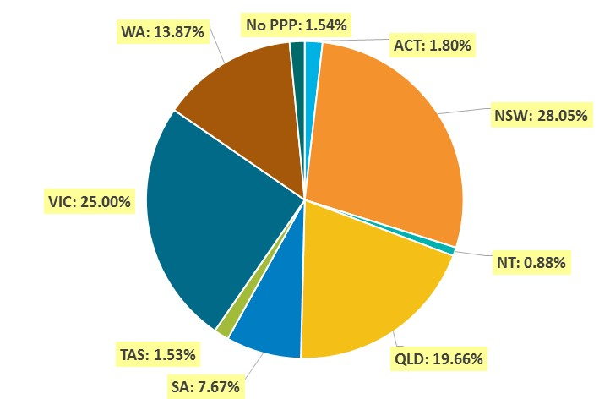

Age Group
- Registration type and subtype
  - Registration by age group
Age group | General | Provisional | Limited |  | Non-practising | Total
Age group | General | Provisional | Postgraduate training or supervised practice | Teaching or research | Non-practising | Total
U - 25 | 1,931 |  | 7 |  | 14 | 1,952
25 - 29 | 4,325 |  | 30 |  | 171 | 4,526
30 - 34 | 3,705 | 1 | 22 |  | 189 | 3,917
35 - 39 | 2,848 | 4 | 11 |  | 113 | 2,976
40 - 44 | 2,133 | 8 | 5 | 1 | 69 | 2,216
45 - 49 | 1,691 | 3 | 4 |  | 39 | 1,737
50 - 54 | 1,242 | 2 |  |  | 30 | 1,274
55 - 59 | 918 |  | 1 |  | 32 | 951
60 - 64 | 531 |  |  |  | 38 | 569
65 - 69 | 192 |  |  |  | 16 | 208
70 - 74 | 48 |  |  |  | 4 | 52
75 - 79 | 9 |  |  |  |  | 9
80+
Total | 19,573 | 18 | 80 | 1 | 715 | 20,387

  - Registration by age group
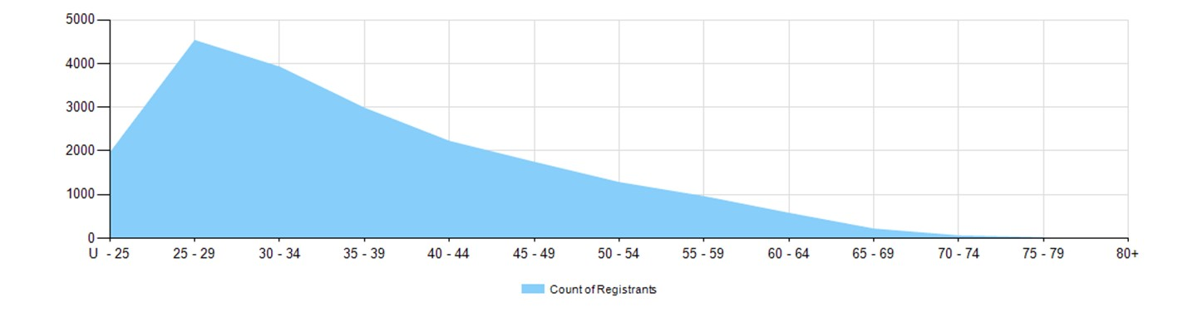

Gender
- Registration type
  - Gender by state and territory by registration type
Gender | Registration type | Subtype | ACT | NSW | NT | QLD | SA | TAS | VIC | WA | No PPP | Total
Female | General |  | 319 | 5,013 | 157 | 3,500 | 1,326 | 272 | 4,539 | 2,470 | 220 | 17,816
Female | Provisional |  | 1 | 7 |  | 1 |  |  | 5 | 2 |  | 16
Female | Limited | Postgrad training or supervised practice | 2 | 30 | 1 | 13 | 1 |  | 16 | 12 |  | 75
Female | Limited | Teaching or research | 1 |  |  |  |  |  |  |  |  | 1
Female | Non-practising |  | 6 | 137 | 4 | 154 | 62 | 8 | 122 | 114 | 71 | 678
Total female |  |  | 329 | 5,187 | 162 | 3,668 | 1,389 | 280 | 4,682 | 2,598 | 291 | 18,586
Male | General |  | 38 | 519 | 17 | 332 | 172 | 32 | 404 | 225 | 18 | 1,757
Male | Provisional |  |  |  |  |  | 1 |  |  | 1 |  | 2
Male | Limited | Postgrad training or supervised practice |  | 2 |  | 2 |  |  | 1 |  |  | 5
Male | Non-practising |  |  | 11 |  | 7 | 2 |  | 9 | 4 | 4 | 37
Total male |  |  | 38 | 532 | 17 | 341 | 175 | 32 | 414 | 230 | 22 | 1,801
Total |  |  | 367 | 5,719 | 179 | 4,009 | 1,564 | 312 | 5,096 | 2,828 | 313 | 20,387

- Percentage
  - Registrants by gender percentages
Gender | ACT | NSW | NT | QLD | SA | TAS | VIC | WA | No PPP | Total
Female | 89.6% | 90.7% | 90.5% | 91.5% | 88.8% | 89.7% | 91.9% | 91.9% | 93.0% | 91.2%
Male | 10.4% | 9.3% | 9.5% | 8.5% | 11.2% | 10.3% | 8.1% | 8.1% | 7.0% | 8.8%

