Occupational Therapy registrant data: June 2015
Published August 2015

Introduction
The role of the Occupational Therapy Board of Australia (the Board) include:
- registering occupational therapists and students
- developing standards, codes and guidelines for the occupational therapy profession
- handling notifications, complaints, investigations and disciplinary hearings
- overseeing the assessment of overseas trained practitioners who wish to practise in Australia, and
approving accreditation standards and accredited courses of study.
The Board’s functions are supported by the Australian Health Practitioner Regulation Agency (AHPRA). For information about legislation governing our operations see About AHPRA at http://www.ahpra.gov.au/About-AHPRA/What-We-Do/Legislation.aspx.
The Board has analysed its registration data and produced a number of statistical breakdowns about registrants to share with the profession and community. The Board shares these breakdowns regularly.
For more information on occupational therapy registration, please see the Board’s website http://www.occupationaltherapyboard.gov.au/Registration.aspx

Contents
Occupational therapy practitioners – registration type and sub type by state or territory 3
Occupational therapy practitioners – percentage by principal place of practice 3
Occupational therapy practitioners – registration type and sub type by age group 4
Occupational therapy practitioners – by age group 5
Occupational therapy practitioners – registration type and sub type by gender 6
Occupational therapy practitioners – percentage by gender 7

Occupational therapy practitioners – registration type and sub type by state or territory
Occupational therapy practitioner |  |  | Principal place of practice
Registration type | Registration subtype | ACT |  | NSW | NT | QLD | SA | TAS | VIC | WA | No PPP | Total
General |  | 286 |  | 4,693 | 154 | 3,189 | 1,282 | 271 | 4,083 | 2,378 | 164 | 16,500
Provisional |  | 1 |  | 21 |  | 6 | 1 |  | 5 | 7 |  | 41
Limited | Postgraduate training or supervised practice | 7 |  | 27 | 1 | 19 | 3 |  | 17 | 13 | 1 | 88
 | Teaching or research |  |  |  |  | 1 |  |  |  |  |  | 1
Non-practising |  | 2 |  | 105 | 1 | 118 | 71 | 8 | 104 | 106 | 55 | 570
Total |  | 296 |  | 4,846 | 156 | 3,333 | 1,357 | 279 | 4,209 | 2,504 | 220 | 17,200

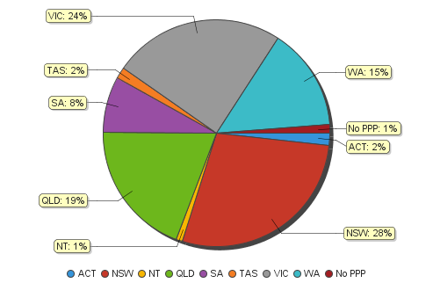
Occupational therapy practitioners – percentage by principal place of practice

Occupational therapy practitioners – registration type and sub type by age group
Occupational therapy practitioners |  | Registration type/ Sub type
Age group | General |  | Provisional | Limited |  |  | Non-practising
 |  |  |  | Postgraduate training or supervised practice | Public interest | Teaching or research |  |  | Total
U - 25 | 1,654 |  |  | 3 |  |  | 21 |  | 1,678
25 - 29 | 3,627 |  |  | 24 |  |  | 157 |  | 3,808
30 - 34 | 3,167 |  | 2 | 31 |  |  | 156 |  | 3,356
35 - 39 | 2,387 |  | 11 | 8 |  | 1 | 89 |  | 2,496
40 - 44 | 1,809 |  | 12 | 11 |  |  | 52 |  | 1,884
45 - 49 | 1,363 |  | 13 | 6 |  |  | 25 |  | 1,407
50 - 54 | 1,090 |  | 2 | 4 |  |  | 18 |  | 1,114
55 - 59 | 835 |  | 1 | 1 |  |  | 21 |  | 858
60 - 64 | 392 |  |  |  |  |  | 22 |  | 414
65 - 69 | 149 |  |  |  |  |  | 7 |  | 156
70 - 74 | 25 |  |  |  |  |  | 2 |  | 27
75 - 79 | 2 |  |  |  |  |  |  |  | 2
80+
Total | 16,500 |  | 41 | 88 |  | 1 | 570 |  | 17,200

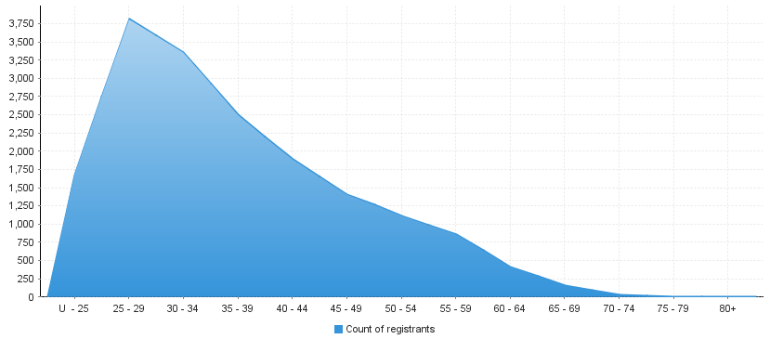
Occupational therapy practitioners – by age group
Age group | U - 25 | 25 - 29 | 30 - 34 | 35 - 39 | 40 - 44 | 45 - 49 | 50 - 54 | 55 - 59 | 60 - 64 | 65 - 69 | 70 - 74 | 75 - 79 | 80+
Count of registrants | 1,678 | 3,808 | 3,356 | 2,496 | 1,884 | 1,407 | 1,114 | 858 | 414 | 156 | 27 | 2

Occupational therapy practitioners – registration type and sub type by gender
Occupational Therapy Practitioner |  |  | Principal place pf practice
Gender | Registration type | Registration sub types | ACT | NSW | NT | QLD | SA | TAS | VIC | WA | No PPP | Total
Female | General |  | 258 | 4,282 | 136 | 2,935 | 1,143 | 246 | 3,751 | 2,177 | 155 | 15,083
 | Provisional |  | 1 | 20 |  | 6 | 1 |  | 5 | 7 |  | 40
 | Limited | Postgraduate training or supervised practice | 7 | 26 | 1 | 17 | 2 |  | 16 | 13 |  | 82
 |  | Public interest
 |  | Teaching or research
 | Non-practising |  | 2 | 99 | 1 | 113 | 68 | 8 | 98 | 105 | 53 | 547
Sub Total |  |  | 268 | 4,427 | 138 | 3,071 | 1,214 | 254 | 3,870 | 2,302 | 208 | 15,752
Male | General |  | 28 | 411 | 18 | 254 | 139 | 25 | 332 | 201 | 9 | 1,417
 | Provisional |  |  | 1 |  |  |  |  |  |  |  | 1
 | Limited | Postgraduate training or supervised practice |  | 1 |  | 2 | 1 |  | 1 |  | 1 | 6
 |  | Public interest
 |  | Teaching or research |  |  |  | 1 |  |  |  |  |  | 1
 | Non-practising |  |  | 6 |  | 5 | 3 |  | 6 | 1 | 2 | 23
Sub Total |  |  | 28 | 419 | 18 | 262 | 143 | 25 | 339 | 202 | 12 | 1,448
Total |  |  | 296 | 4,846 | 156 | 3,333 | 1,357 | 279 | 4,209 | 2,504 | 220 | 17,200

Occupational therapy practitioners – percentage by gender
Occupational therapy practitioners | Principal place of practice
Gender | ACT | NSW | NT | QLD | SA | TAS | VIC | WA | No PPP | Total
Female | 90.54% | 91.35% | 88.46% | 92.14% | 89.46% | 91.04% | 91.95% | 91.93% | 94.55% | 91.58%
Male | 9.46% | 8.65% | 11.54% | 7.86% | 10.54% | 8.96% | 8.05% | 8.07% | 5.45% | 8.42%

